
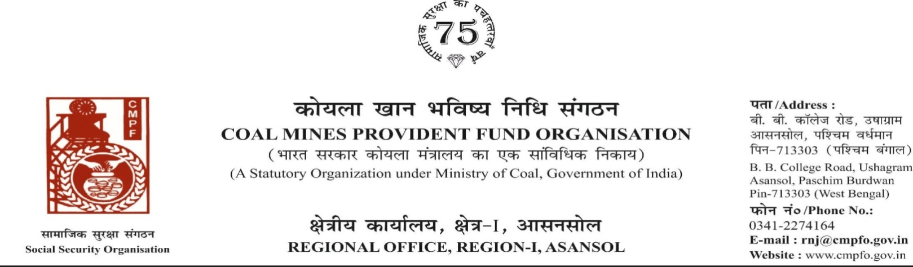
Ref. : CPF/118/Misc/RNJ/LC/OUT/R-I/ASN/ Date :09-/10/2025
Reminder-1
To,
The Regional Commissioner
C.M.P.F
PO-Gupteswar Shaktinagar
Pin-482001
Jabalpur (MP)

Sub:- Inter Regional Transfer of Ledger Card, DA, PS -3 & 4.
Sir,
In view of the revised Procedures prescribed in Procedure Office Order No-35 Dated-12.02.1975 of CMPF Commissioner,Dhanbad, I am to state that the Ledger Cards of the following members along with Declaration in Form "A" Form-I (Pen),PS-3 & 4 may kindly be forwarded to this office as the member(s) is /are working in this region.
It may kindly be ensured that the posting in the Ledger Cards may be made updated for the periods the member was working in your Region.
SL. No | Name of the Member | CMPF A/C No | Name of the colliery where the member is currently working in | Name of the colliery where the member had earlier worked in | Name of the Company | Period of Posting
1 | Sri MANOJ KUMAR MANDAL | BLP/73/1497 | SONEPUR BAZARI PROJECT  (RNJ/34) | JHILIMILI COLLIERY | SECL | 09-12-2015  TO  17-03-2016
 |  |  |  | SHIWANI  COLLIERY | SECL | 17-03-2016  TO  20-02-2019
In light of this, we kindly request you to do the needful action and kindly arrange the transfer of his ledger card from previous working zones and update the records accordingly.
Thank you for your attention to this matter.
Encl. :Posting Details (Two copies )
Yours faithfully

Assistant Commissioner

